PRODUCTION PLAN

# Staff

|  |  |
| --- | --- |
| Name | Acton |
| Bernat Casañas | Leader |
| Eudald Garrofé | Design |
| Miquel Suau | Programming |
| Jordi Pardo | Management |
| Josep Sánchez | Art |
| Arnau Falgueras | UI |
| Roger Pérez | QA |
| Marc Ramos | Audio |

# Schedule

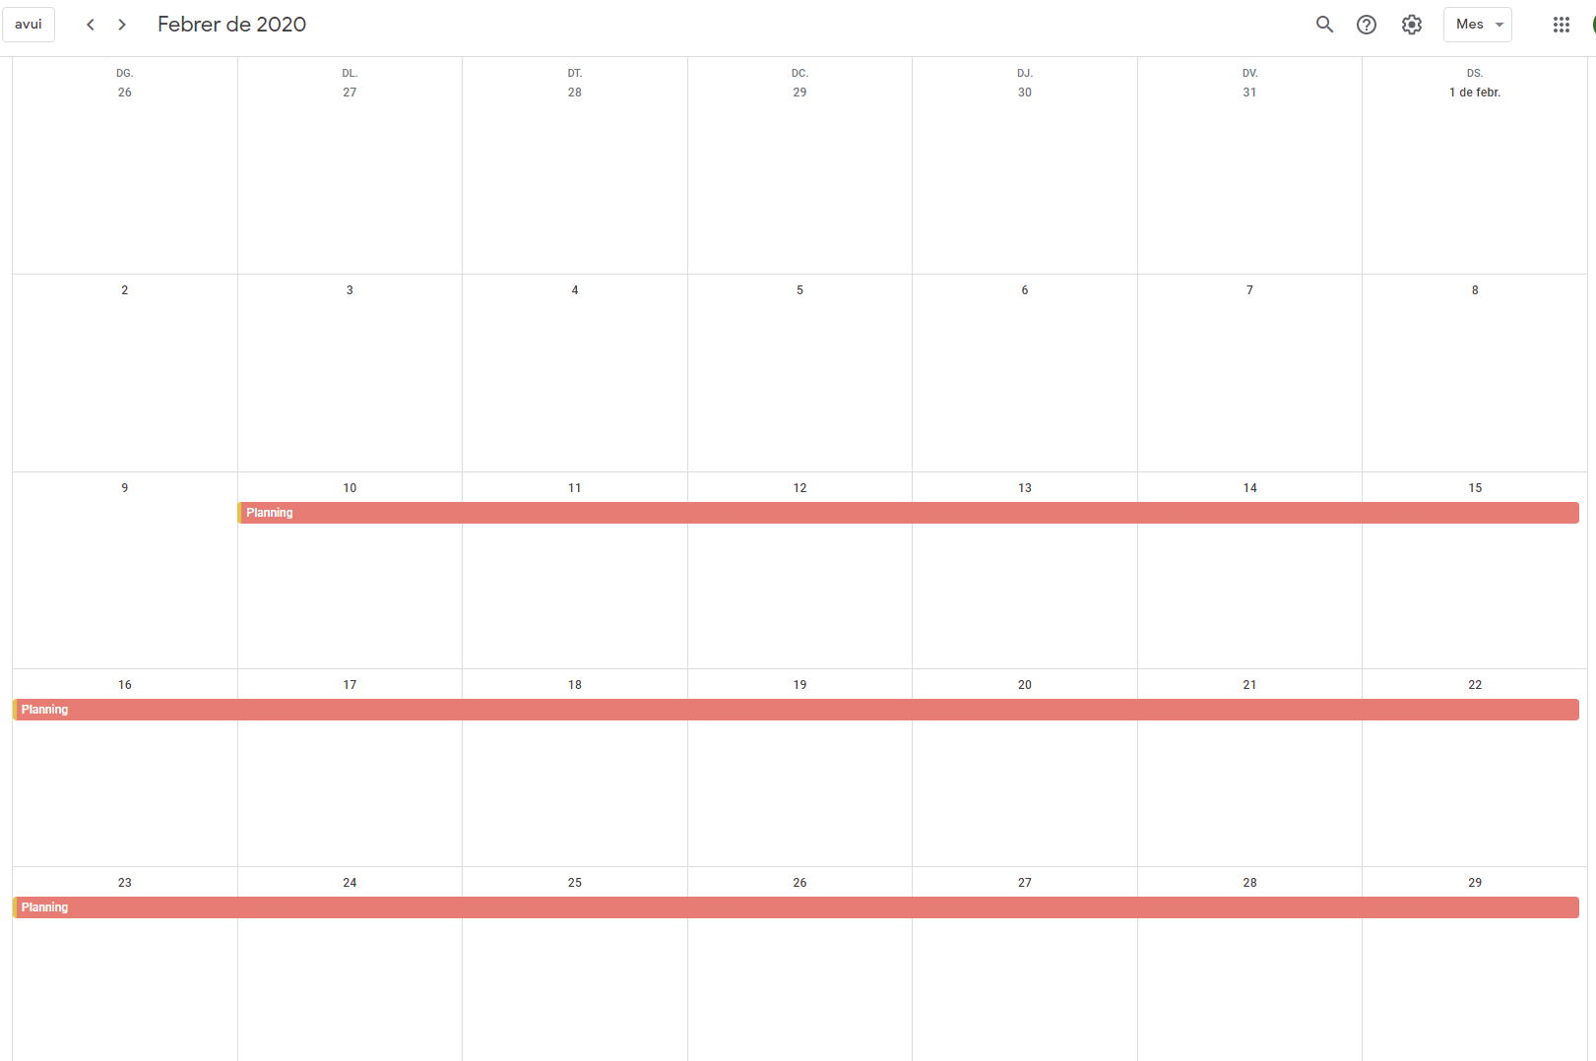

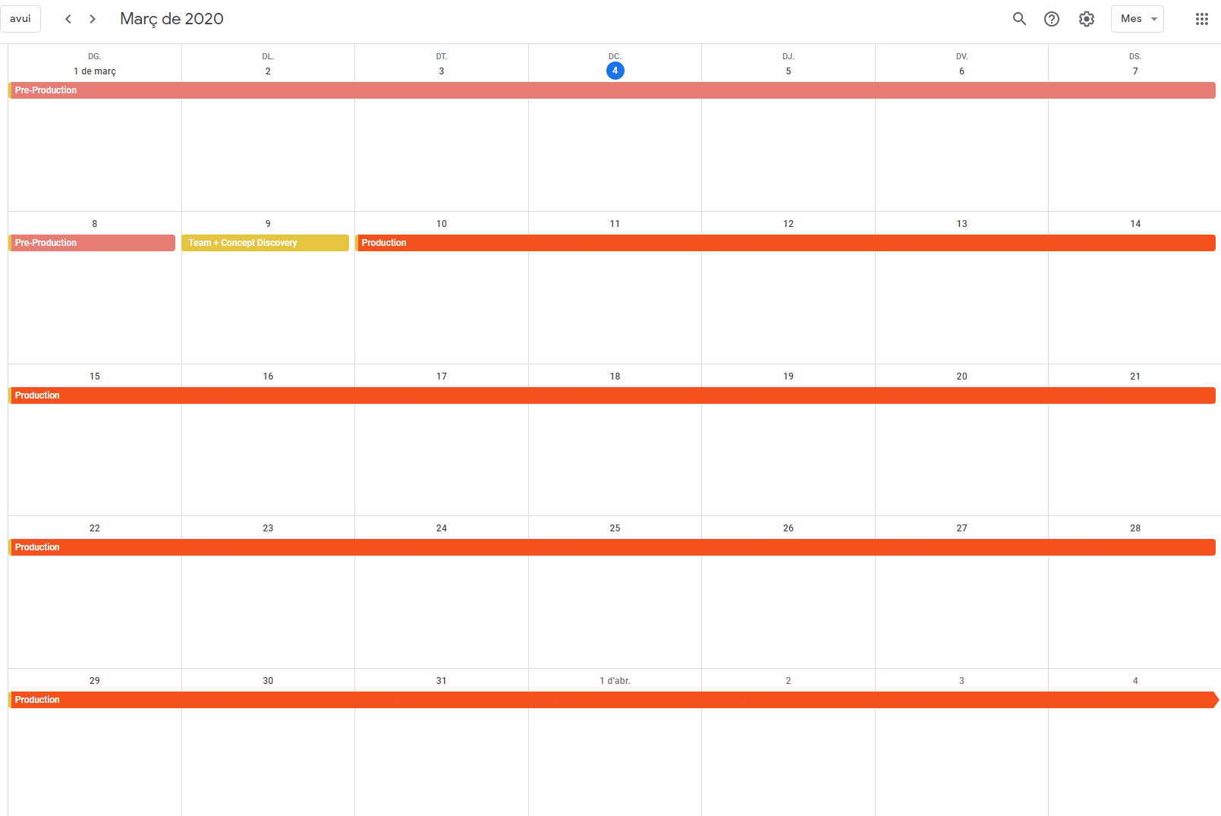

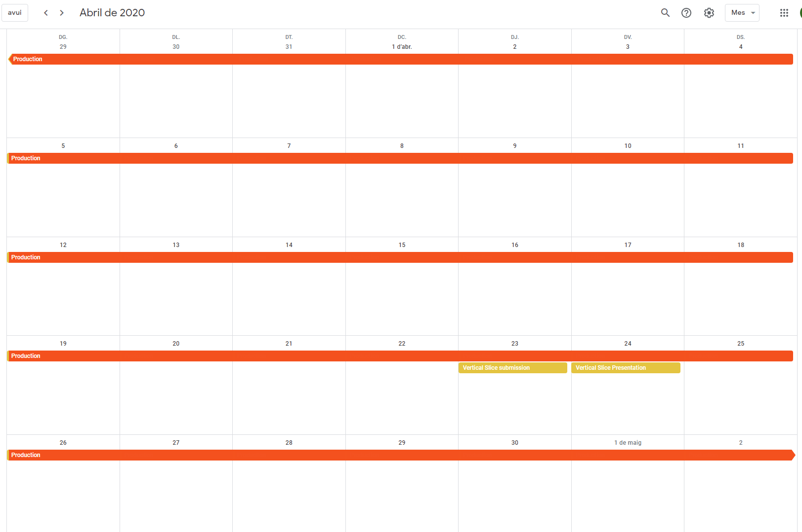

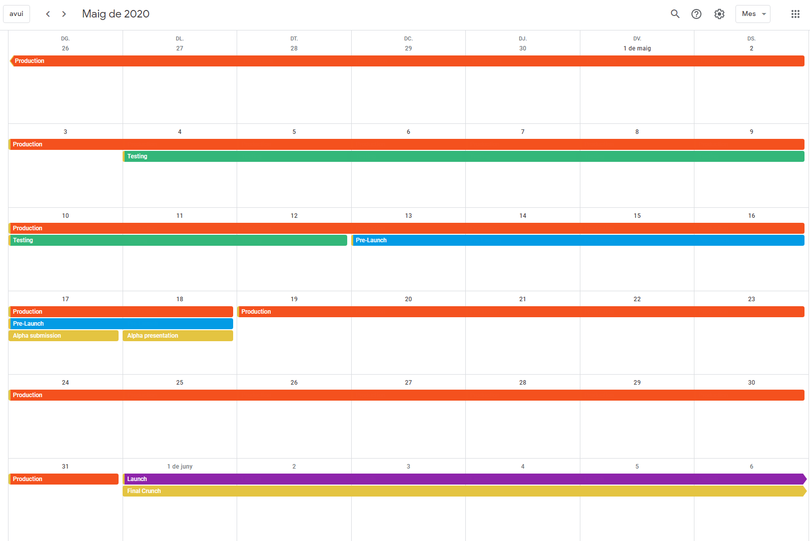

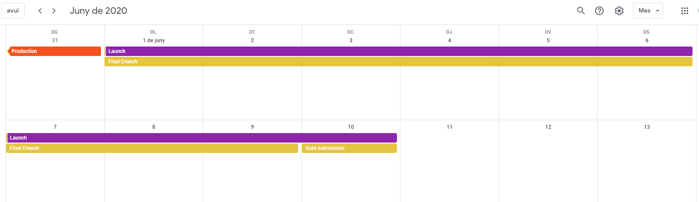

Due to the bad quality of photos, the link below contains the calendar with all the planning.

<https://calendar.google.com/calendar/b/1?cid=ZG0yNXFrM2dmbm1iZGIwY2d2ODNmZnFlOGtAZ3JvdXAuY2FsZW5kYXIuZ29vZ2xlLmNvbQ>

# Contingency List:

|  |  |  |
| --- | --- | --- |
| PROBLEM | PROBABILITY | PROTOCOL |
| Short time member Absence | High | A talk to him would be adequate |
| Long-time member Absence | Low | If it continues, a re-orientation of his role would be a good solution. |
| Non/Low working member | From previous experience, Medium Probability | A talk explaining what can happen to al group if they don’t work |
| Weekly sprint not competed | Mid | It can be a problem of the manager, or him. Anyway, the solution is a talk between the manager and the worker |
| External Delivery not delivered | Low | An urgent meeting to talk about what have we done bad |
| HacknPlan not used adequately | High | First of all, we need to meet up to see where is everybody |
| Members low comunication | Medium | A meeting to say the importance to comunicate |
| Harder to balance the game than expected | Mid | The designer must prepare an alternative to solve the problem |
| No time for Q&A sessions | Low-Mid | QA department should say what’s going wrong |
| The tasks are not accomplishing as expected | Low | Is there a big quantity of work? We probably need to change the volume of work |